 | 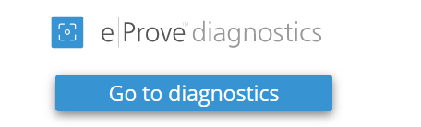 |  | 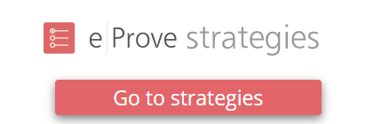
Data from survey results assist with developing a school’s needs assessment. | The Title I Diagnostic can be found under the ALSDE Content Tab in eProve Diagnostics. The Title I Diagnostic is for Title I Schools only. |  | Both Title I and Non-Title Schools must complete an ACIP in eProve Strategies.
Parent Surveys  - Title I Schools must use the required Title I Parent Survey that can be found under the ALSDE Content Tab in both English and Spanish  - Non-Title Schools may use any parent survey/inventory found under the AdvancED/Cognia Certified Content Tab or utilize another survey of their choice. | Title I Schools Only  - Schoolwide or Targeted Assistance Title I Comprehensive Needs Assessment |  | Title I Schools and Non-Title Schools  - This is an annual plan that contains strategic themes, objectives, critical initiatives, activities, financial resources, etc.
Teacher Surveys or Inventories  Title I Schools and Non-Title Schools  - Schools may use any teacher survey/inventory found under the AdvancED/Cognia Certified Content Tab or utilize another survey of their choice. | Title I Schools Only  - Schoolwide or Targeted Assistance Title I ACIP Assurances |  | Title I Schools and Non-Title Schools  - The Annual Implementation Plan within eProve Strategies will function as your school’s yearly ACIP.
Student Surveys or Inventories  Title I Schools and Non-Title Schools  - Schools may use any student survey/inventory found under the AdvancED/Cognia Certified Content Tab or utilize another survey of their choice. | Title I Schools Only  - Schoolwide or Targeted Assistance Title I Parent and Family Engagement Plan |  | Title I Schools and Non-Title Schools  - If a Title I School, be sure to include all federal dollars used in the financial resources section of the plan.
Title I Schools Only
- Schoolwide or Targeted Assistance Title I Coordination of Resources- Comprehensive Budget
Title I Schools ACIP Checklist |  | Non-Title Schools ACIP Checklist
______ Administer Title I Parent Surveys (Spring or Fall)  ______ Administer Staff and Student Surveys (Spring or Fall)  ______ Complete the applicable Title I Diagnostic  (Schoolwide or Targeted Assistance)  ______ Complete plan in eProve Strategies |  | ______ Administer Parent Surveys (Spring or Fall)  ______ Administer Staff and Student Surveys (Spring or Fall)  ______ Complete plan in eProve Strategies

