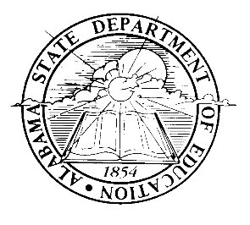

Certification for
Required Annual Meetings of Title I Parents

This is to certify that all Title I schools with the Montgomery Public Schools have conducted their required Annual Meeting of Title I Parents in accordance with Every Student Succeeds Act (ESSA), signed into law on December 10, 2015, as well as the January 2009 State Guidance on Selected Parental Involvement Requirements and subsequent technical assistance. The Annual Meetings were used to inform parents of their school’s participation in Title I and to explain the right of parents to be involved. The meetings explained the purpose of the 1% set-aside funds for parental involvement and parents’ right to be involved in how these monies are allotted for parental involvement activities.

This is to further certify that at each Title I school, the person conducting the Annual Meeting was knowledgeable about Title I, Part A.

Name of Person Making This Certification:

Position:

Title I School | Date of Meeting | Person Conducting  Meeting | Position
Note: This certification must be posted to your school system’s e-GAP Document Library

